SAVEETHA SCHOOL OF ENGINEERING
SAVEETHA INSTITUTE OF MEDICAL AND TECHNICAL SCIENCES
INSTITUTE OF CSE
CSA15- CLOUD COMPUTING AND BIG DATA ANALYTICS
LIST OF EXPERIMENTS
6. Create a simple cloud software application for Payroll Processing System using any
Cloud Service Provider to demonstrate SaaS include the necessary fields such as Name
of the employee, experience in present org , over all experience, basic pay, HRA, DA,
TA, net pay, gross pay etc.
INPUT:
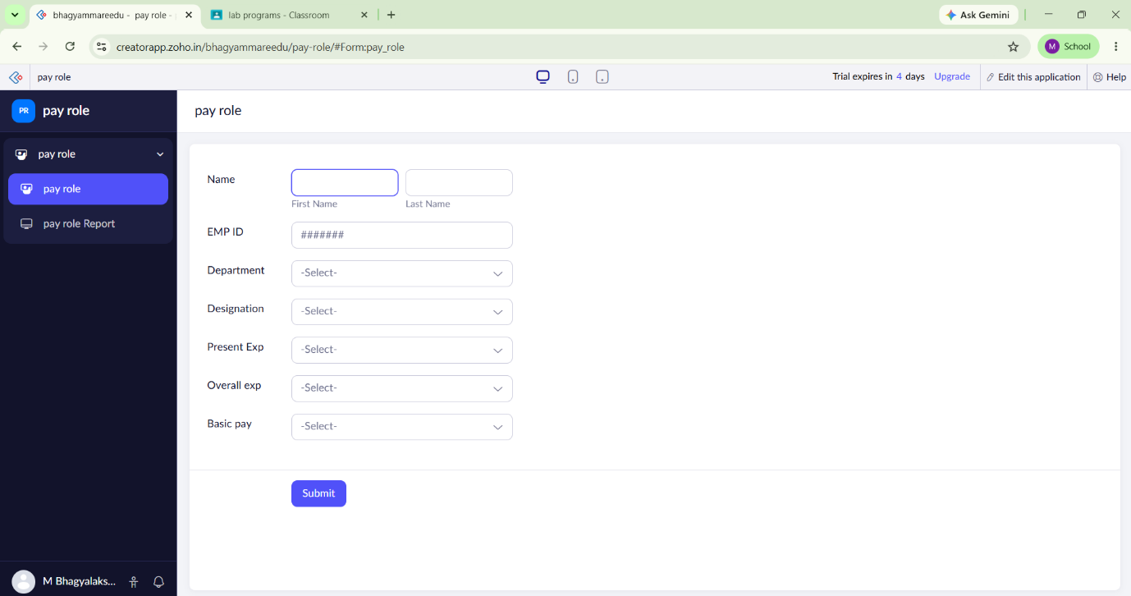

OVER VIEW:
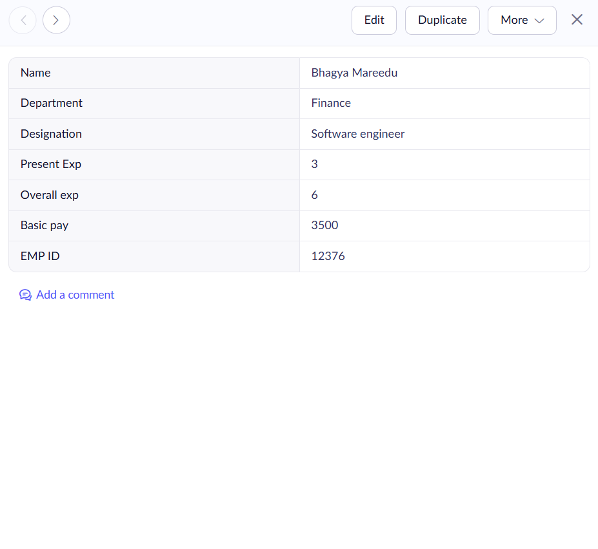
OUT PUT:
